Robot Path-Planning Algorithms for Fully Dynamic Shortest Path Problems Report

//署名+Student ID

# Abstract

D start Lite, LPA Start and IDA Start both are using in path-planning algorithms to find shortest path. The purpose of this experiment is to understanding the advantage and disadvantage of three different algorithms in shortest path find. And the influences of g-value, rhs-value, km-vlue and heuristic value in algorithm to find shortest path.

# Contents

1. Related Work

1.1．Data structures of D* Lite LPA* and IDA

1.2．C++ cod skeleton

1.3．Detail of D* Lite LPA* and IDA algorithm

2. Result Table

3. Experiments summary

4. User’s Guide

1. **Related Work**

**1.1 Data structures of D* Lite LPA* and IDA**

**Main.cpp**

DStarLite* g_dsl = nullptr;

LpaStar* g_lpas = nullptr;

bool findPath();

void updateData(bool fromMazeToMap);

// modify copyMazeToDisplayMap &copyDisplayMapToMaze, if fromMazeToMap is ture, copy date from maze to //map,flase, copy data from map to maze.

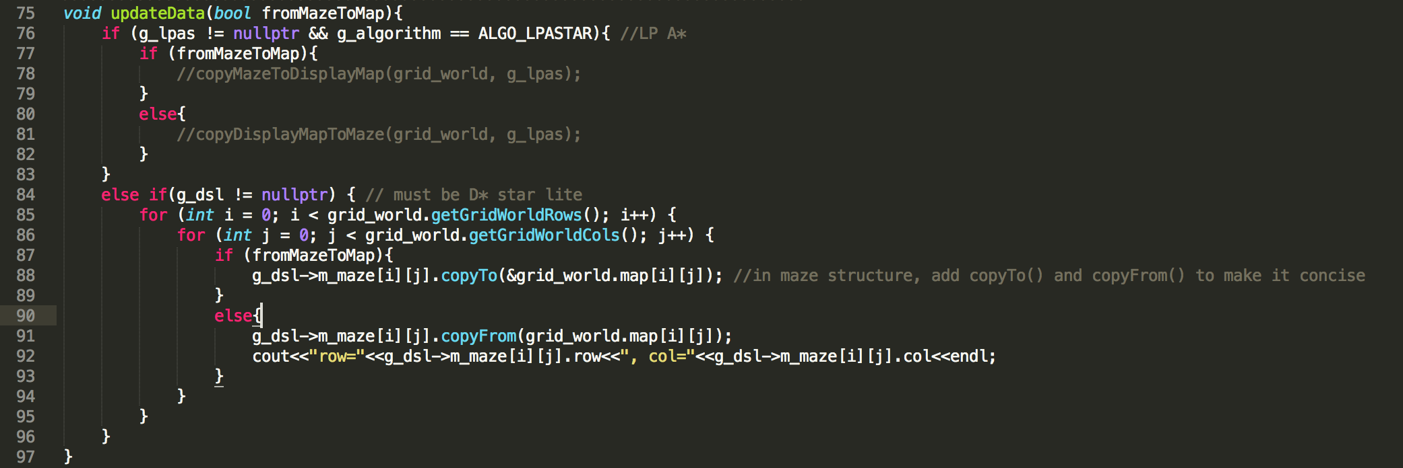

void updateH(); // call D*Lite updateH()

void updateKey();//calle D*Lite updateKey()

**Gridworld.h**

char m_searchStatus; //-1 not found, 0 reset, 1 found the path show

void setSearchStatus(char status); // set m_searchStatus

**PriorityQueue**

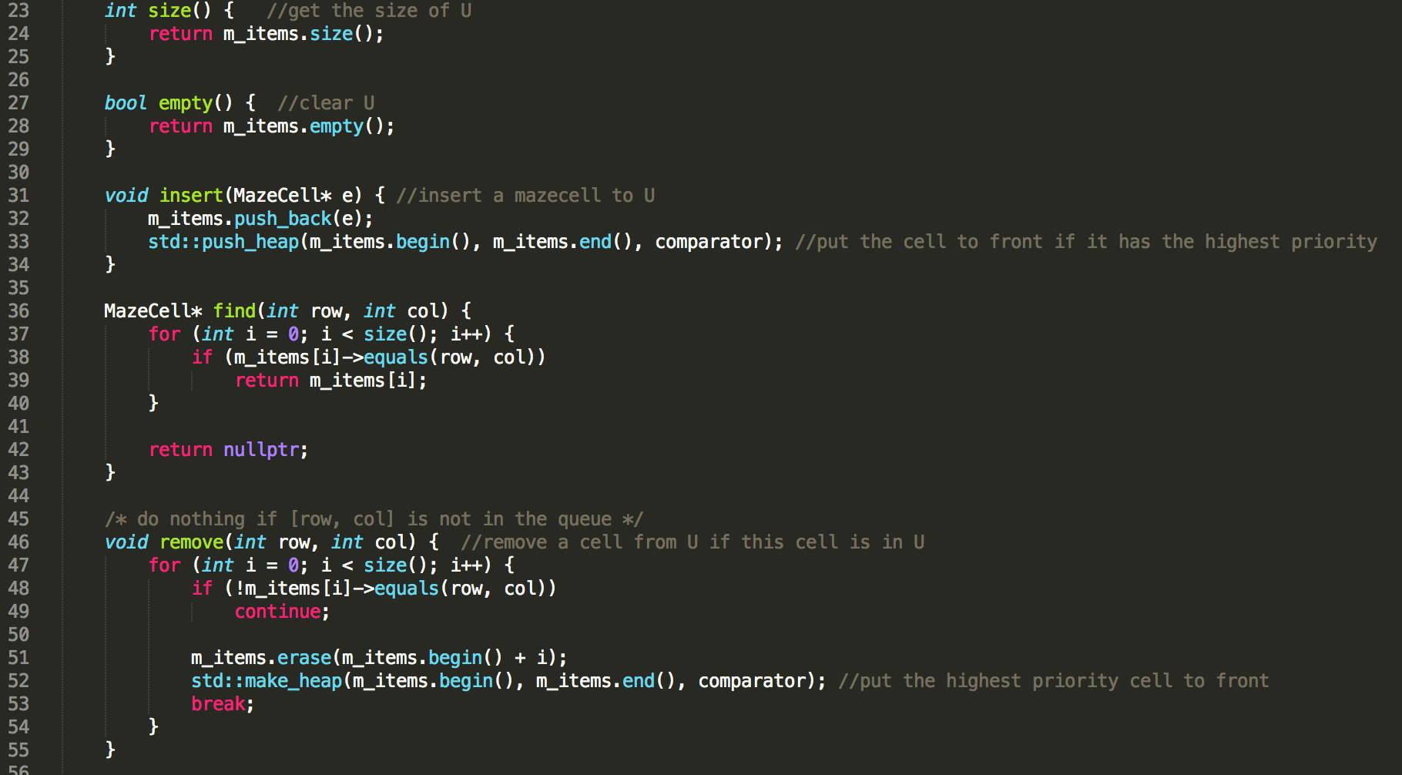

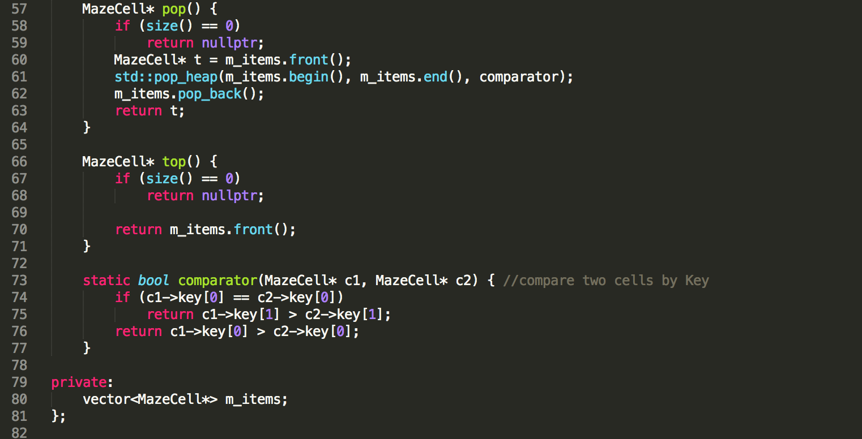

**globalVariables.h**

We create a struct MazeCell in globalVariables for all of algorithms:

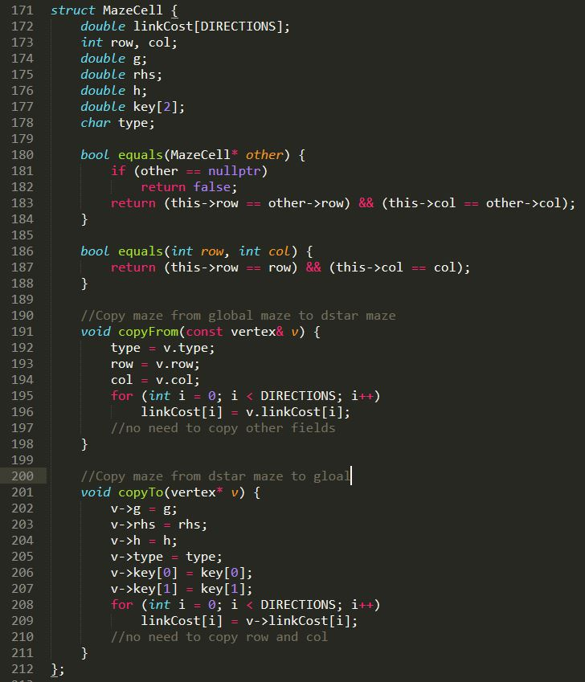

**2. C++ code skeleton**

**Main.cpp**

We modified some parts of Main.cpp to call our algorithm.

Changes in runsimulation():

case 1001: //press Enter key to calculate the shortest path.

If (findPath()=1) show the path;

// we define a new member m_searchStatus(-1,0,1) to define the finding result status.

Else show “the goal can not be reached”; //

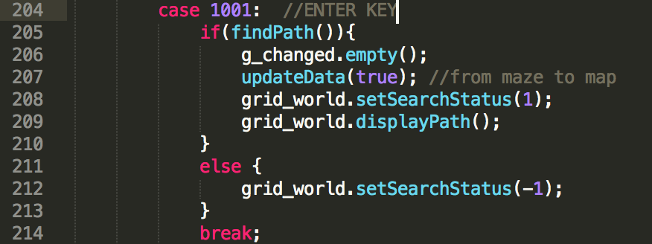

Case 108:

// call D*Lite final algorithm, set m_searchStatus to 0, be ready to calculate the shortest path.

Case 106:

//call IDA*

Case 107:

//call LPA*

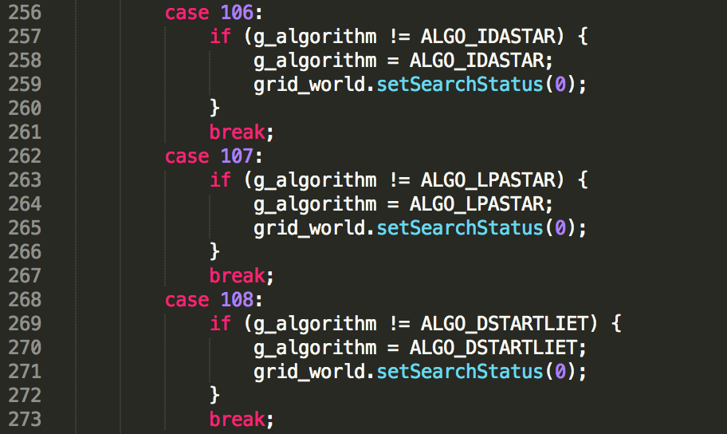

Add a new function

bool findPath(): this findPath() is defined and used by the main function to tell if the g_dsl->findPath() has successfully executed. If g_dsl->findPath() found the shortest path, it returns ture. The same as LAP*, IDA*.

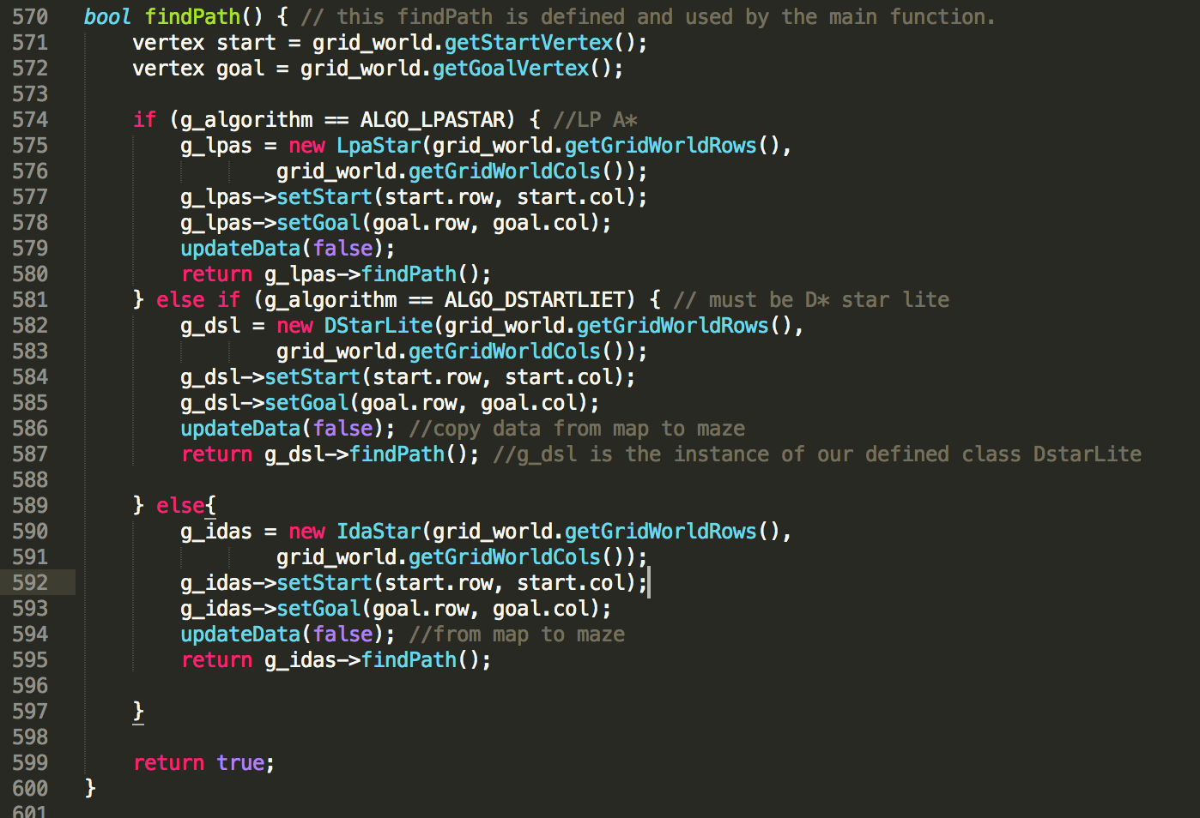

**Gridword.cpp**

In displayHeader(): add m_searchStatus,

m_searchStatus=0,reset and press enter to run;

m_searchStatus=1, show the path;

m_searchStatus=-1, can not find the path.

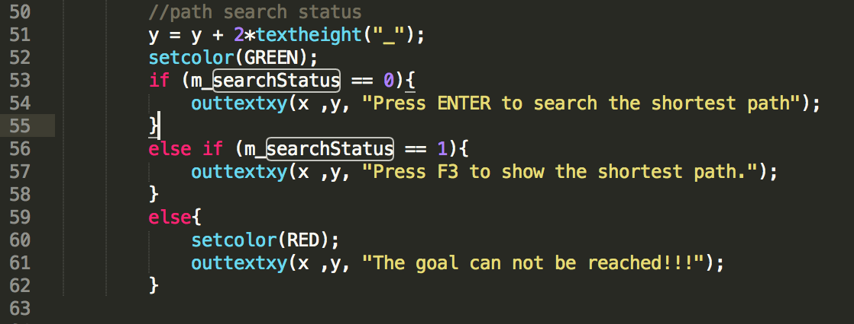

**Dstart Lite.cpp**

Step1 Create grildword maze vector:

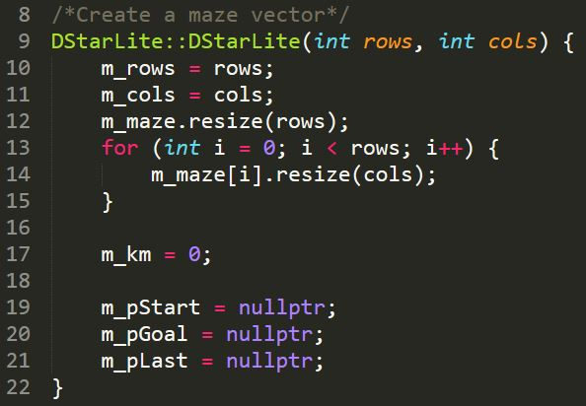

Step2 set start and set goal:

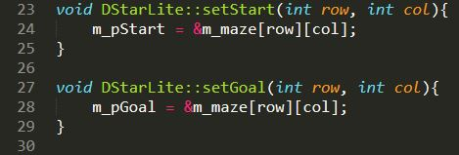

Step3 create initialize function:

m_U.empty(); // Empty priority queue

m_km = 0;// Set km value equal to zero

m_pGoal->rhs = 0;// rhs(Sgoal)=0;

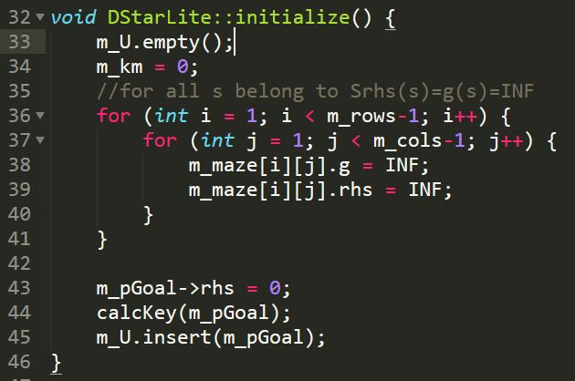

Step4 calculate heuristic value and update heuristic value:

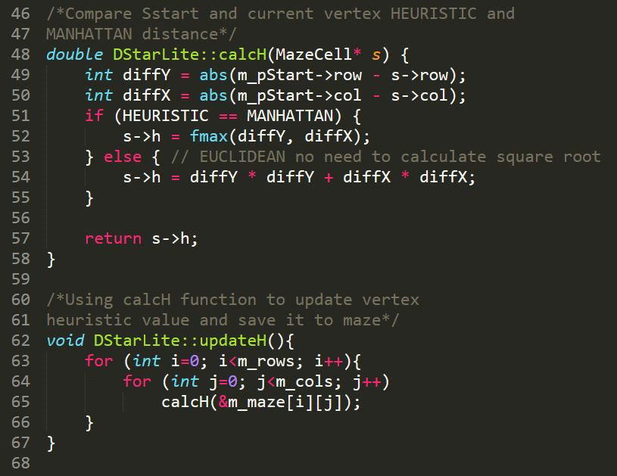

Step5 calculate c(u,s’) value:

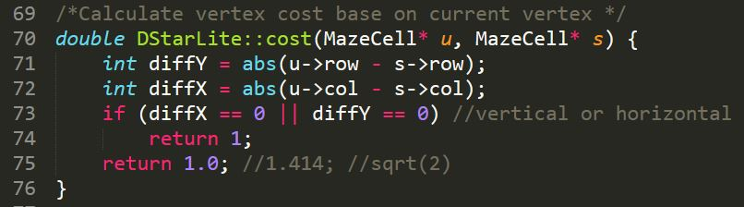

Step6 calculate Key value and update Key value:

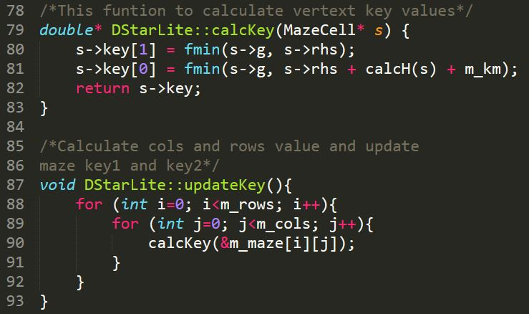

Step7 function for compare the smallest key value:

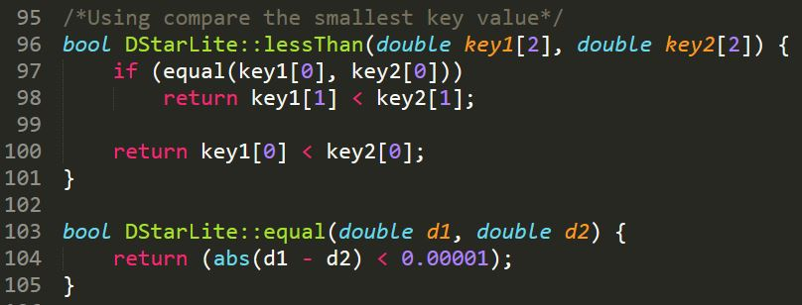

Step8 copy Kold to U.TopKey:

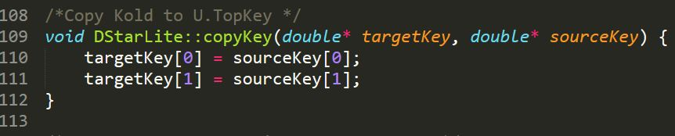

Step9 compare two vertext is same one or not:

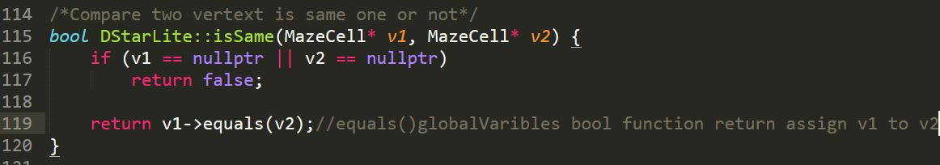

Step10 find all neighbours of current vertex:

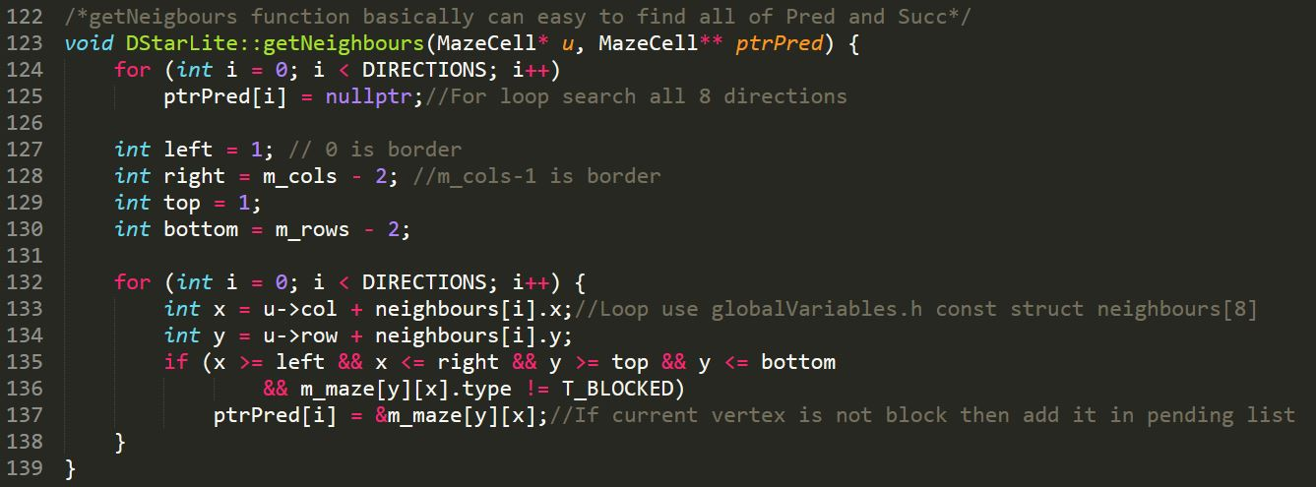

Step11 calculate minin cost pluse g-value:

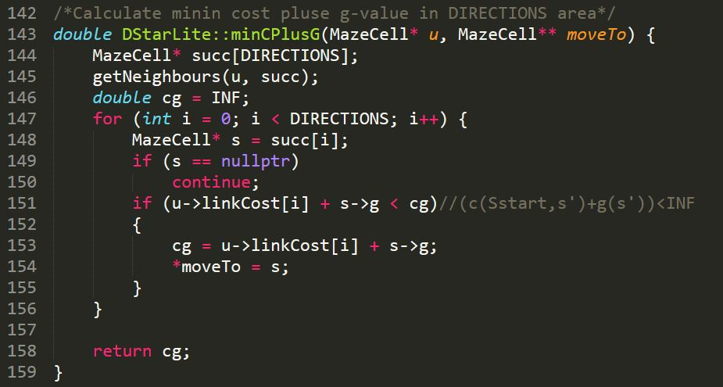

Step12 create function for update vertex:

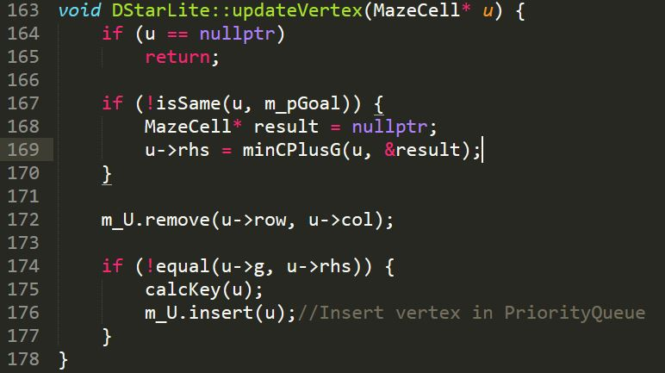

Step13 create function for compute shortest path:

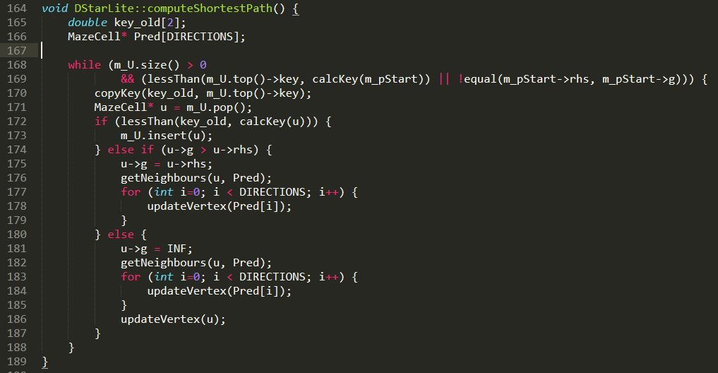

Step 14 create findPath function to replaced Main function in pseudocode:

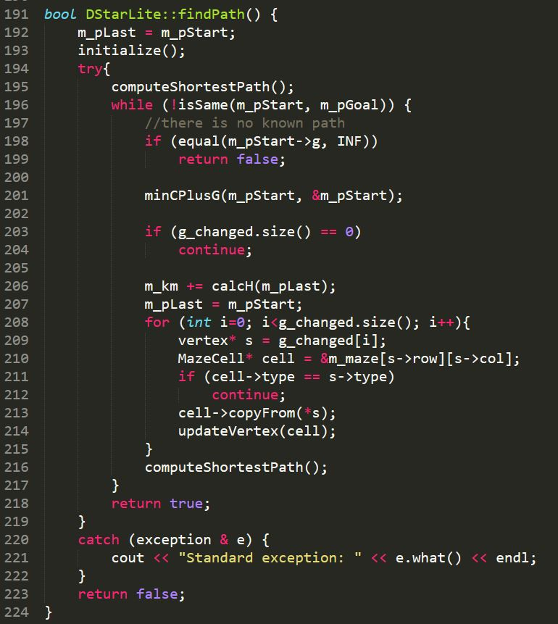

**DStarLite.h**

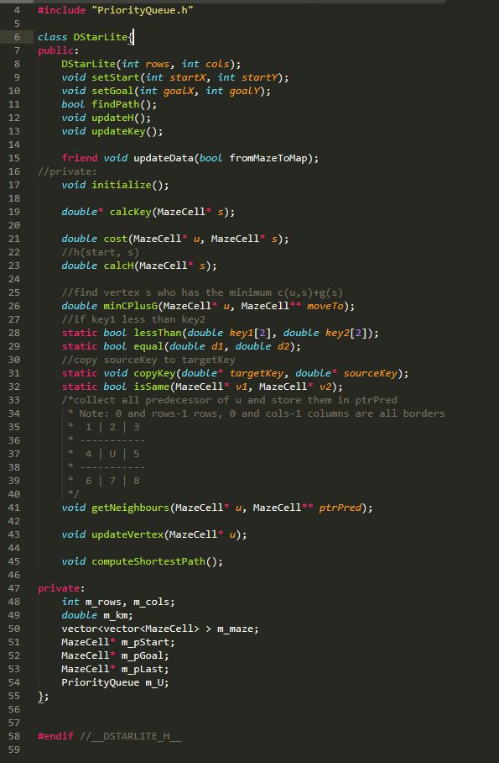

**LPAstart Lite.cpp**

Step1 Create grildword maze vector:

Step2 set start and set goal:

Step3 create initialize function:

m_U.empty(); // Empty priority queue

m_pStart->rhs = 0; // rhs(Sstart)=0;

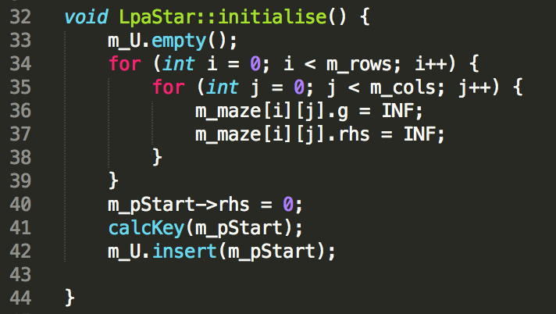

Step4 calculate heuristic value and update heuristic value: 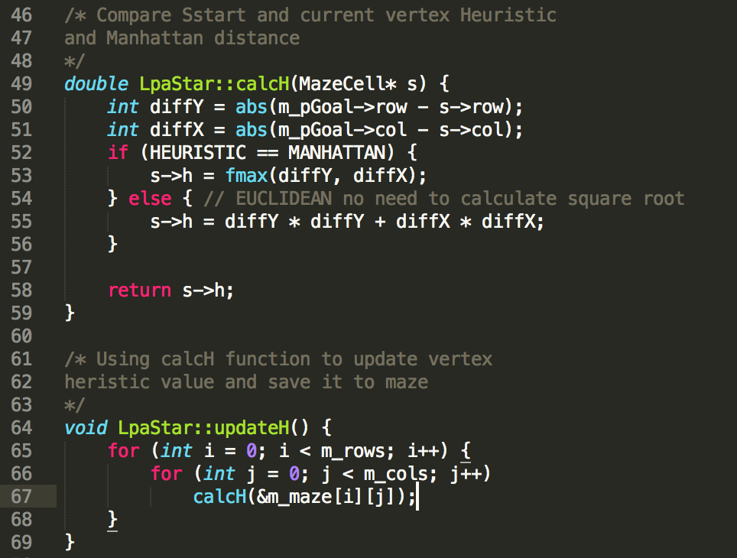

Step5 calculate Key value and update Key value:

*-ComputeShortestPath*

Step6 use D*Lite function lessThan() to compare the smallest key value.

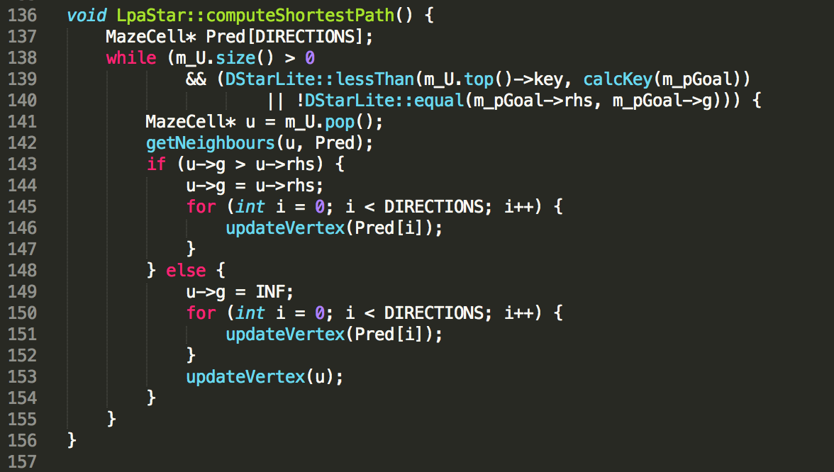

*-find path*

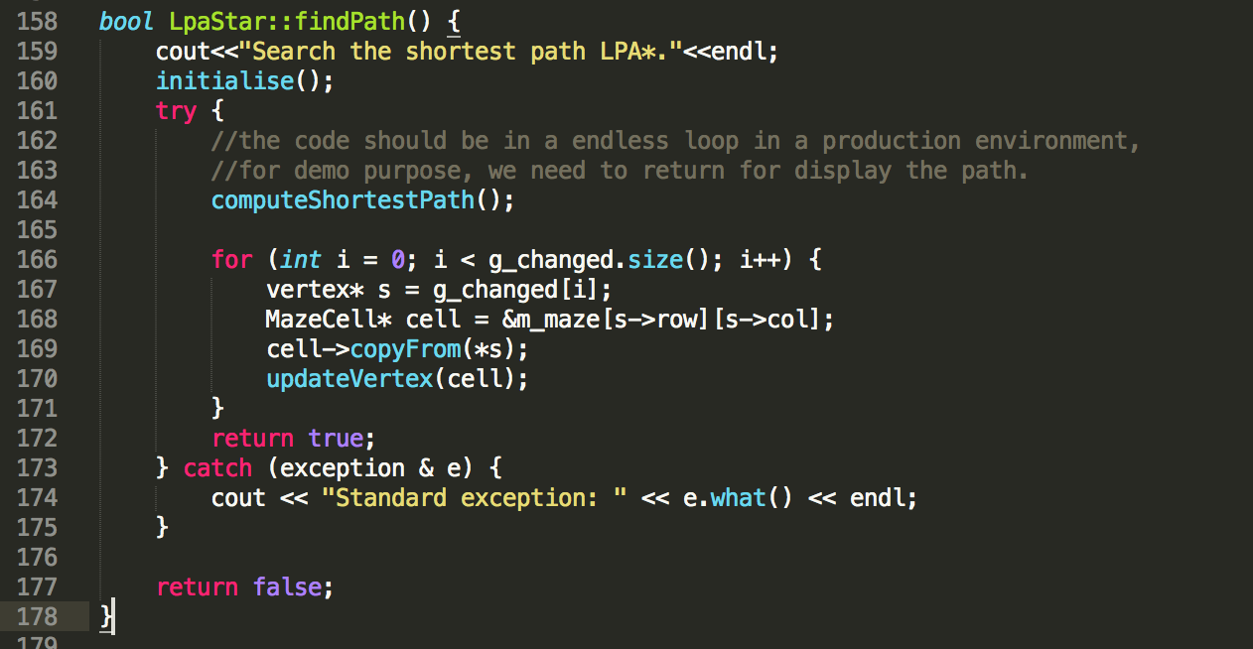

**LPAstarLite.h**

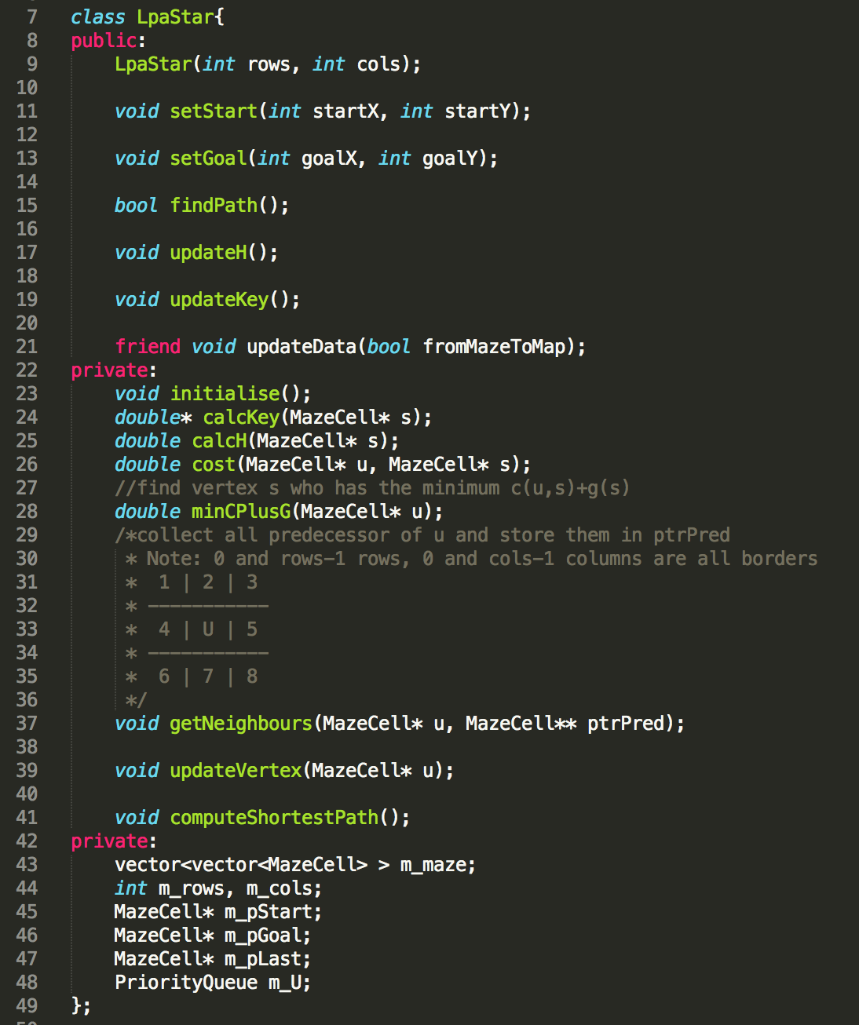

**3． Detail of D* Lite Algorithm, LPA* and IDA**

**D*Lite: shortest path**

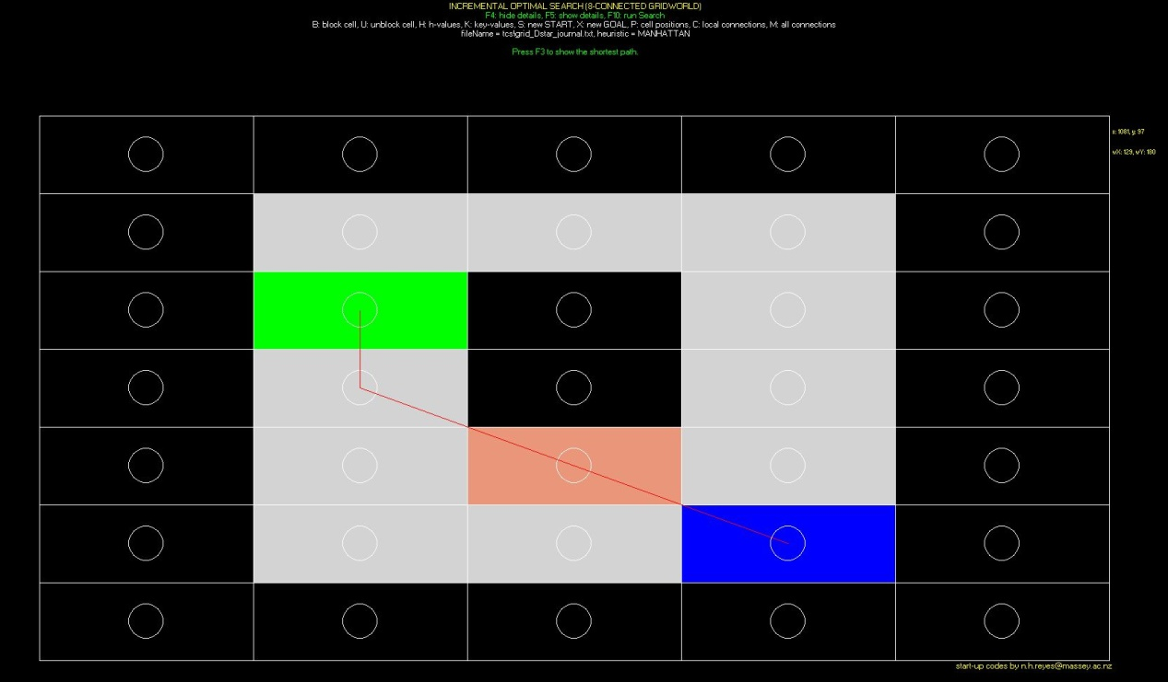

**D*Lite: g-value, rhs-value and h-value**



**D*Lite: key values**

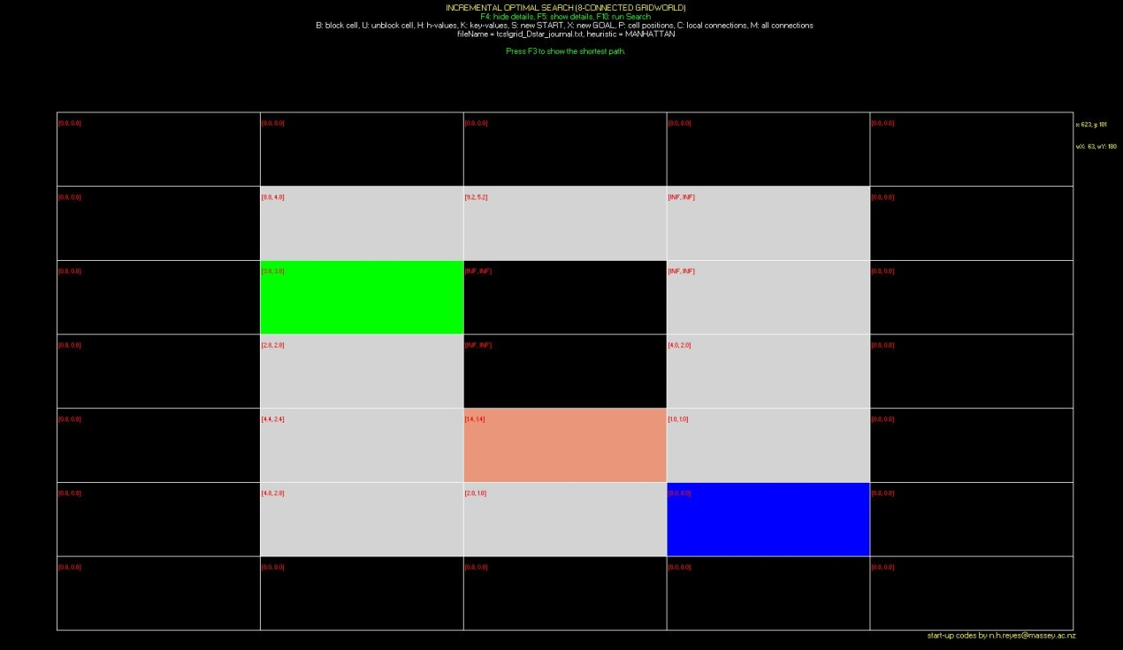

**D*Lite: Path relationship**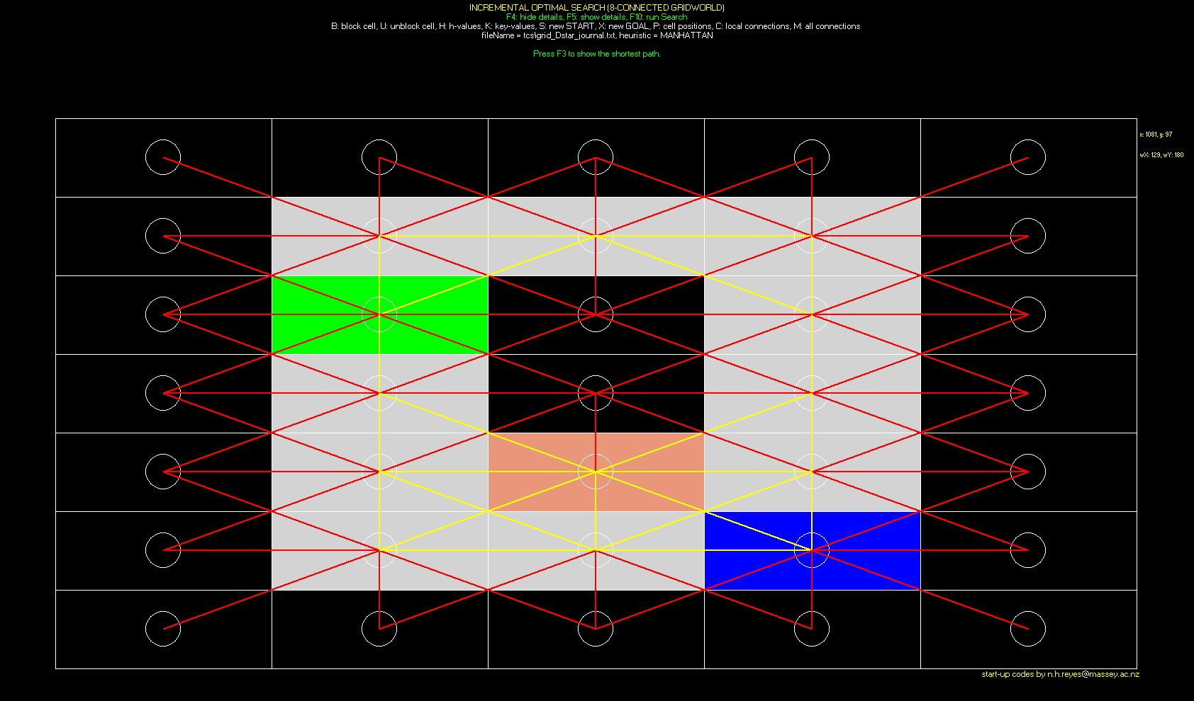

**LPA*: shortest path**

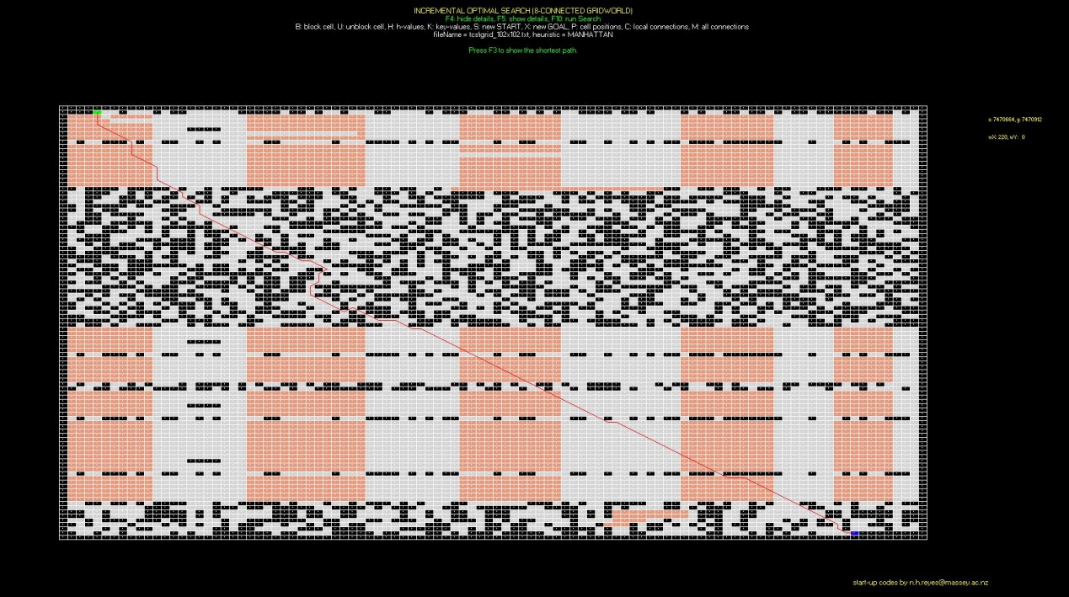

**IDA: shortest path**

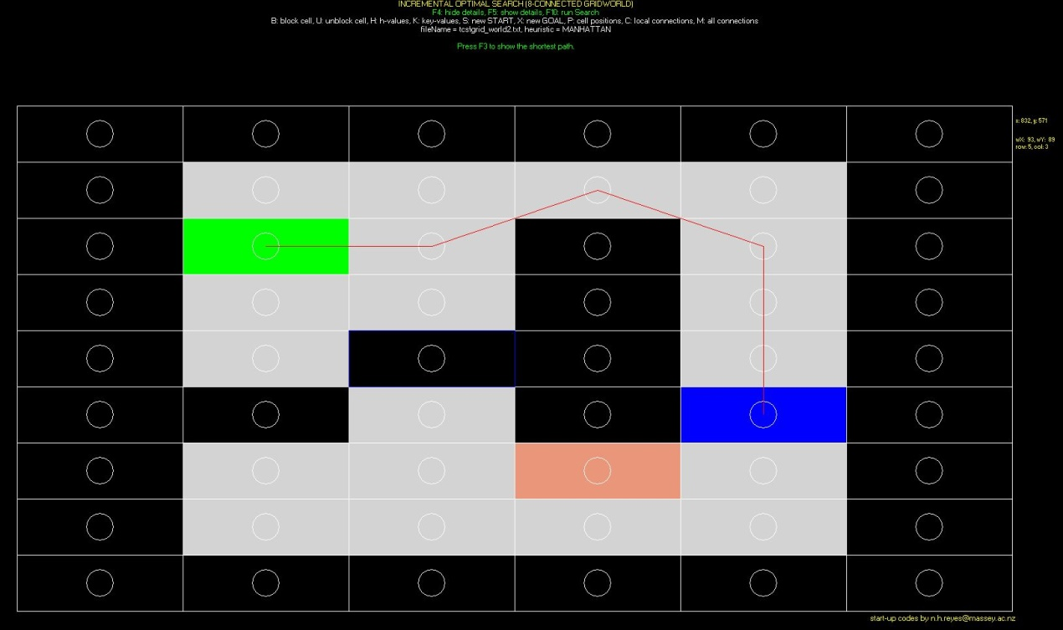

**IDA: h-value**

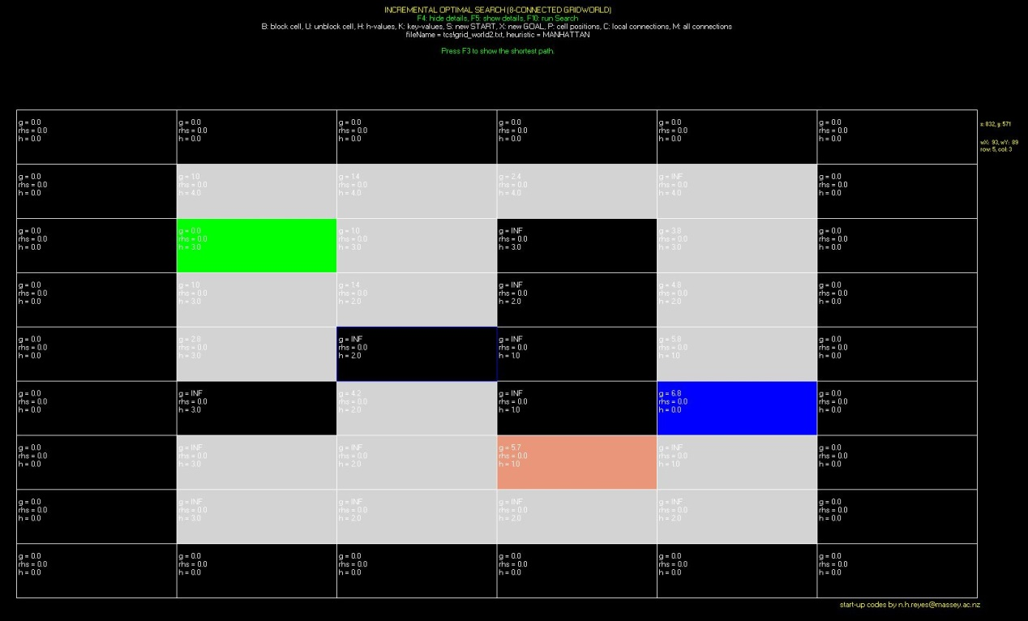

**IDA: Path**

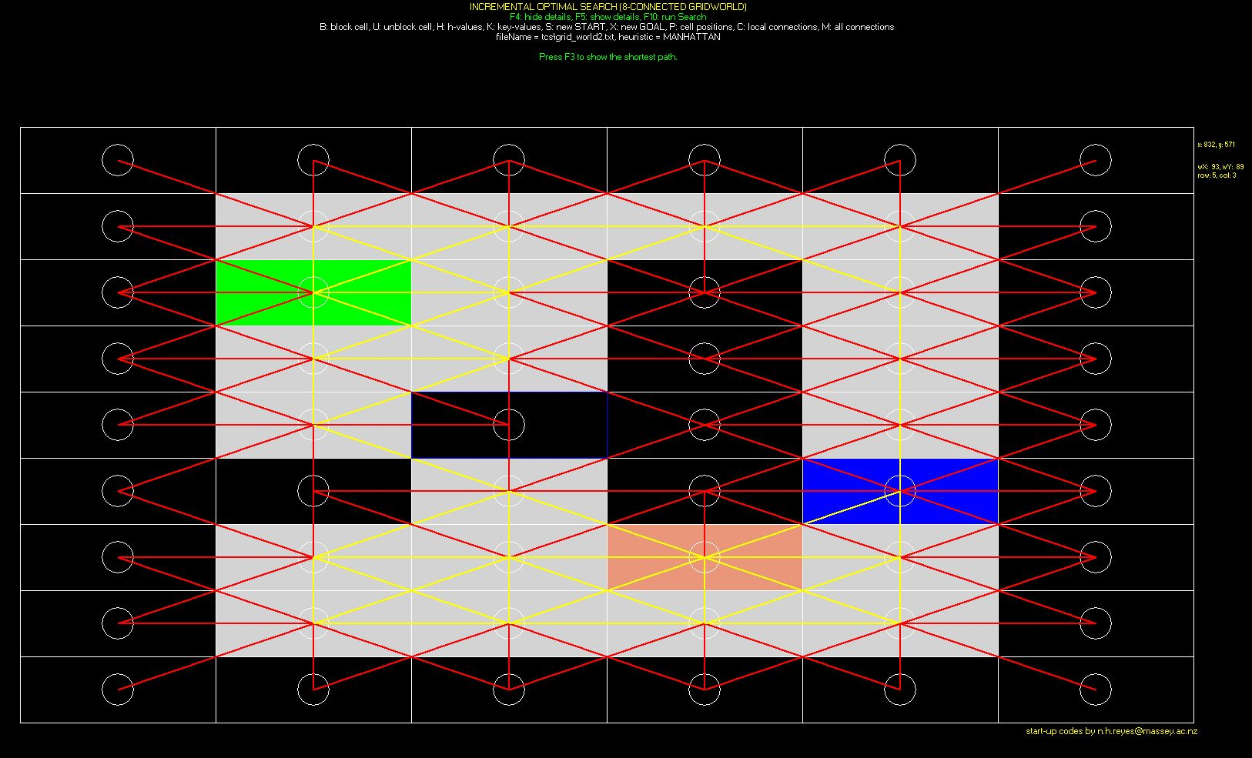

**1.2 Result Table**

Gridworld: __ grid_102x102.txt___

Heuristic: Euclidean distance

|  |  |  |  |  |  |  |
| --- | --- | --- | --- | --- | --- | --- |
|  | **Algorithm** | **Max. Queue length** | **Path length** | **No. of state expansions** | **Vertex accesses** | **Actual Running Time (msec.)** |
| 1 | A* using the Strict Expanded List | Initial search, second search | Initial search, second search | Initial search, second search | Initial search, second search | Initial search, second search |
| 2 |  |  |  |  |  |  |
| 3 | D* Lite Final Version | Initial search, second search | Initial search, second search | Initial search, second search | Initial search, second search | Initial search, second search |

Gridworld: ___ grid_102x102.txt____

Heuristic: Manhattan-8 distance

|  |  |  |  |  |  |  |
| --- | --- | --- | --- | --- | --- | --- |
|  | **Algorithm** | **Max. Queue length** | **Path length** | **No. of state expansions** | **Vertex accesses** | **Actual Running Time (msec.)** |
| 1 | A* using the Strict Expanded List | Initial search, second search | Initial search, second search | Initial search, second search | Initial search, second search | Initial search, second search |
| 2 |  |  |  |  |  |  |
| 3 | D* Lite Final Version | Initial search, second search | Initial search, second search | Initial search, second search | Initial search, second search | Initial search, second search |

**1.3 Experiments summary**

针对试验结果进行总结，哪个更快，哪个更省内存，

Through this assignment, we implemented D*Lite final version, LPA* and IDA* algorithms.

* 1. **User’s Guide**

1. Enter Main <gridworld> {MANHATTAN, EUCLIDEAN} {lpa, dlite ida} to start algorthms. Eg: main grid_Dstar_journal.txt MANHATTAN lpa

2. Press ENTER**,** when you change any algorithm or cell position need press ENTER first to initialize the calculation.

1. Can not change map cell position and algorithms during the calculation.

|  |  |  |
| --- | --- | --- |
| Name | Keyboard | Description |
| Show path | F3 | Show shortest path |
| Show detial | F5 | Show g-value, rhs-value and h-value in map |
| Hide detial | F4 | Hide g-value, rhs-value and h-value in map |
| Block Cell | B | Block map cell |
| Unblock Cell | U | Unblock map cell |
| Heuristic value | H | Show heuristic value |
| G value | G | Show g value |
| Key value | K | Show key value |
| Start | S | Change start cell |
| Goal | X | Change goal cell |
| axis value | P | Show cell axis value |
| Cell connection | C | Show map cell connetion relationship |
| All cell connection | M | Show all cell connection relationshop on the map |

Specify the data structures used in the different algorithms. //指定不同算法使用的数据结构

Provide a skeleton C++ code for each algorithm (more detailed than the pseudocode of the algorithms provided in class). //提供c++代码的框架流程参照伪代码，比伪代码详细

Using the sample gridworld defined in the D*Lite journal (and also used in the D*Lite tutorial) Include a snapshot of each algorithm run, indicating graphically the path generated, the map of the g-values, rhs-values, keys, and the vertices expanded. //使用D * Lite日志中定义的示例gridworld（也用于D * Lite教程）2. 包括每个算法运行的快照 3. 截图这些值在路径地图中的样式，g值的映射，rhs值，键 ，并扩展顶点（图带不同的点值）。

Tabulate the results of all experiments performed according to the format given. //将程序运行结果制表并列举出所有结果

Discuss briefly the results of all the experiments.//讨论总结实验结果

User’s Guide (simple guide on how to operate the simulation system, short cut keys) //用户指南（关于如何操作模拟系统的简单指南，快捷键）